Lab 2.9.2 - Basic Switch and End Device Configuration

# Topology

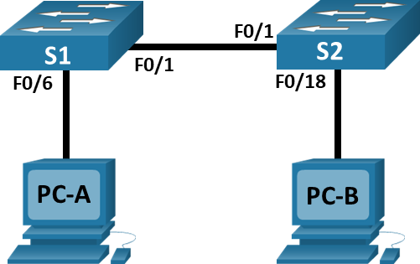

# Addressing Table

|  |  |  |  |
| --- | --- | --- | --- |
| Device | Interface | IP Address | Subnet Mask |
| S1 | VLAN 1 | 192.168.1.1 | 255.255.255.0 |
| S2 | VLAN 1 | 192.168.1.2 | 255.255.255.0 |
| PC-A | NIC | 192.168.1.10 | 255.255.255.0 |
| PC-B | NIC | 192.168.1.11 | 255.255.255.0 |

# Objectives

* Set Up the Network Topology
* Configure PC Hosts
* Configure and Verify Basic Switch Settings

# Background / Scenario

In this lab, you will build a simple network with two hosts and two switches. You will also configure basic settings including hostname, local passwords, and login banner. Use **show** commands to display the running configuration, IOS version, and interface status. Use the **copy** command to save device configurations.

You will apply IP addressing for this lab to the PCs and switches to enable communication between the devices. Use the **ping** utility to verify connectivity.

**Note: Read module 2 from NetAcad course content for examples on the commands used in this Lab. You will find important resources to help you complete the lab.**

# Required Resources

* 2 Switches (Cisco 2960 with Cisco IOS Release 15.0(2) lanbasek9 image or comparable)
* 2 PCs (Windows with terminal emulation program, such as Tera Term)
* Console cables to configure the Cisco IOS devices via the console ports
* Ethernet cables as shown in the topology

# Instructions

* Enter your screenshots/answers below the items highlighted in blue and turn in the completed file without making any changes to the original content.
* Lab must be completed using actual equipment accessed remotely through NetLab or directly on campus. No credit will be awarded for labs submitted using Packet Tracer.
* Once the Lab is graded it cannot be resubmitted for a new grade.

## Set Up the Network Topology (Not required if using NetLab)

In this step, you will cable the devices together according to the network topology.

* + 1. Power on the devices.
    2. Connect the two switches.
    3. Connect the PCs to their respective switches.
    4. Visually inspect network connections.

## Configure PC Hosts

* + 1. Configure static IP address information on the PCs according to the Addressing Table.
    2. Verify PC settings.

## Configure and Verify Basic Switch Settings

* + 1. Console into switch S1. (If Using NetLab, just click on the switch from the topology or open the switch tab from the main NetLab window to gain console access).
    2. Enter the global configuration mode.
    3. Give the switch a name according to the Addressing Table.
    4. Prevent unwanted DNS lookups.
    5. Enter local passwords. Use **class** as the privileged EXEC password and **cisco** as the password for console access.
    6. Configure and enable interface vlan1, also known as the switch virtual interface (**SVI**), according to the Addressing Table.
    7. Enter a login message of the day (MOTD) banner to warn about unauthorized access.
    8. Save the configuration from random access memory (RAM) to non volatile RAM (NVRAM).
    9. Close Configuration Window.
    10. Configure switch S2 by repeating items a to i above

.

* + 1. Use the appropriate commands to test your configuration.Provide screenshots of the commands output to verify your work:
       1. Status of F0/1 interface on S1. (10 points)

UP

* + - 1. Status of F0/6 interface on S1. (10 points)

UP

* + - 1. Status of F0/1 interface on S2. (10 points)

UP

* + - 1. Status of F0/18 interface on S2. (10 points)

DOWN

* + - 1. Status of interface VLAN 1 on S1. (10 points)

UP

* + - 1. Status of interface VLAN 1 on S2. (10 points)

UP

* + 1. From PC-A or PC-B, ping interface vlan1 (SVI) of S1 and S2. Provide screenshots of the pings to verify your results. (10 points)

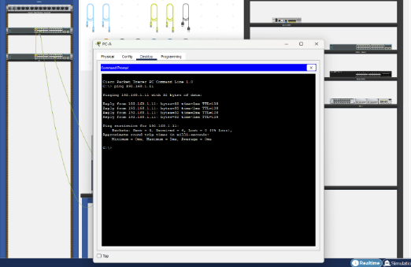

* + 1. Provide a screenshot of a ping from PC-A to PC-B. (10 points)
    2. Display the IOS version and another useful switch information on S1, provide a screenshot of the result, the screenshot doesn’t have to include the whole output. (10 points)
    3. Display the current configuration file on S1, provide a screenshot of the result, the screenshot doesn’t have to include the whole output. (10 points)

# Reflection Question

Why some FastEthernet ports on the switches are up and others are down?

The FastEthernet ports are up and down when an ethernet cable is connected unless manually shut down by and from the admin.Type your answers here.

What could prevent a ping from being sent between the PCs?

Because the ip address entered could be wrong or the PC could deny ping requests.Type your answers here.

End of Document